The Processes of Project Lead the Way
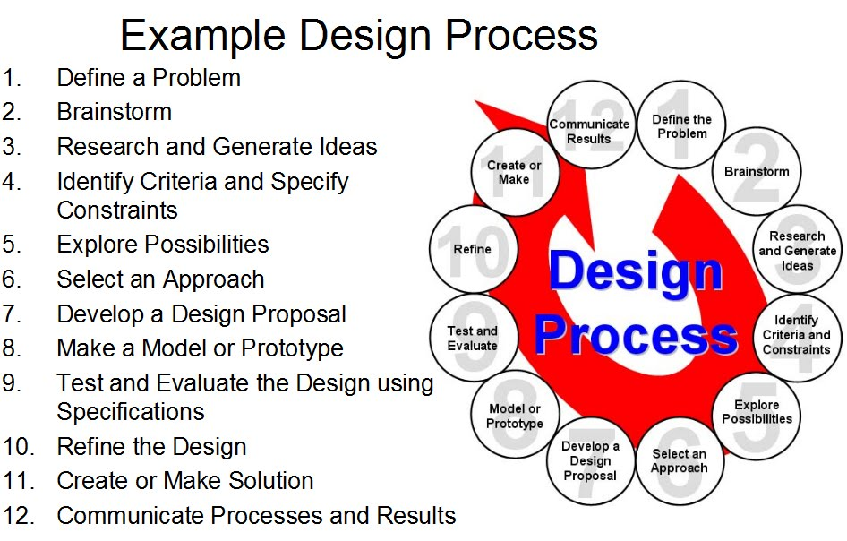
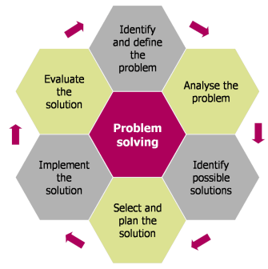 | Basic Problem Solving  - Identify what the actual problem is to be solved. Define it specifically.  - Analyze the problem, breaking down each aspect of it so that you understand all of the aspects involved. Make sure you know all constraints to solving it.  - Brainstorm with your teammates and find possible solutions. Each solution should be researched.  - Choose the solution with the greatest possibility for success.  - Implement the solution that you have chosen to solve this problem.  - Look over what you did, and make changes to allow for greater future success.

