Start a new part, ENGLISH FOLDER, STANDARD(IN).IPT and the middle plane.
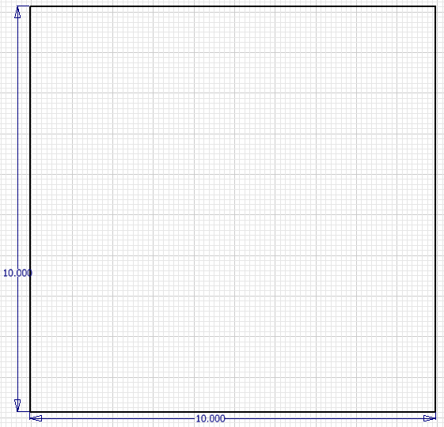
- The Target project starts by making a 10 inch square
- Place a two point rectangle on the sketch pad.
- Dimension the Left side to 10 inches.
- Dimension the Bottom side to 10 inches.
To place the third dimension, we must go to the 3D screen. To do this we must click FINISH SKETCH at the top right of the screen.
- Extrude the rectangle 10 inches to create a block.
- Look at the front side of the block.
SAVE YOUR PART RIGHT NOW AS TARGET
- Right click on it and choose NEW SKETCH.
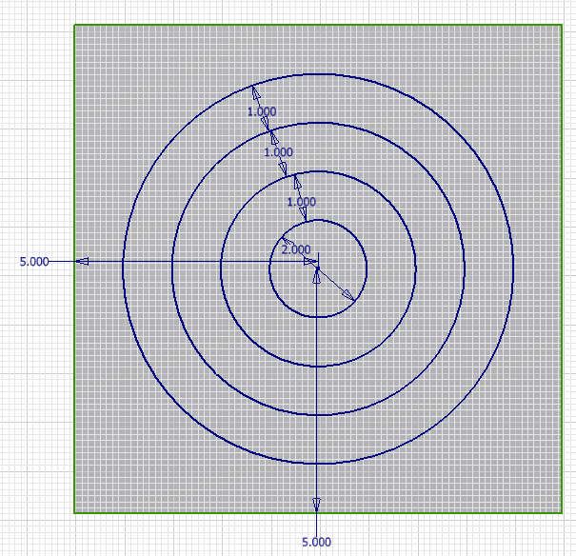
It is now time to place a circle on the front of the block.
- Draw a center point circle.
- Make the diameter 2 inches
- Center the circle
  - Dimension the center point 5 inches from bottom and the left side.
- Make a concentric circle larger than the first one.
  - Remember, concentric circles share the same center point.
- Dimension these two circles 1 inch apart.
- Continue to do this until you have circles like you see here on the right.
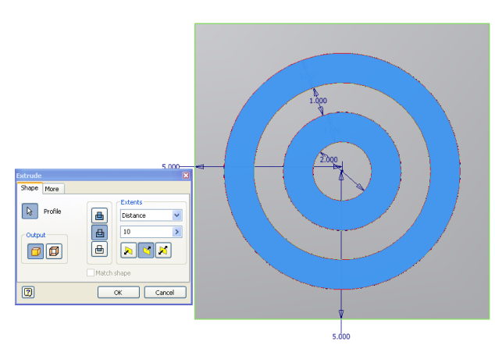
- Cut the outside ring and the 2nd ring like you see below, and using the extrude command.

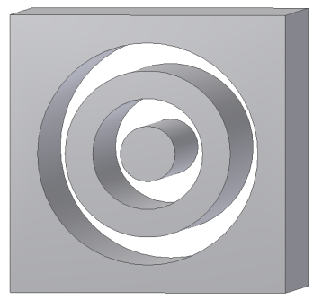
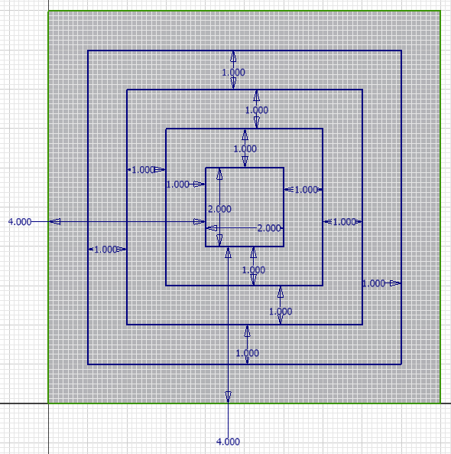
Next up, we are going to draw a new sketch on the RIGHT side of the block, and we are going to attempt a SQUARE TARGET using two point rectangles.
- Start with a two point rectangle in the center that is 2 inches by 2 inches.
- Dimension the left side of the block 4 inches from the left.
- Dimension the bottom of the block 4 inches from the bottom.
- Make a rectangle outside of the first one, and set all for sides 1 inch apart from the inside block.
- Continue to do this until you have 4 squares that are dimensioned like you see here on the right side of the paper.
- When you have completed this sketch and all of the dimensions, Finish the sketch and get ready to EXTRUDE you sketch.

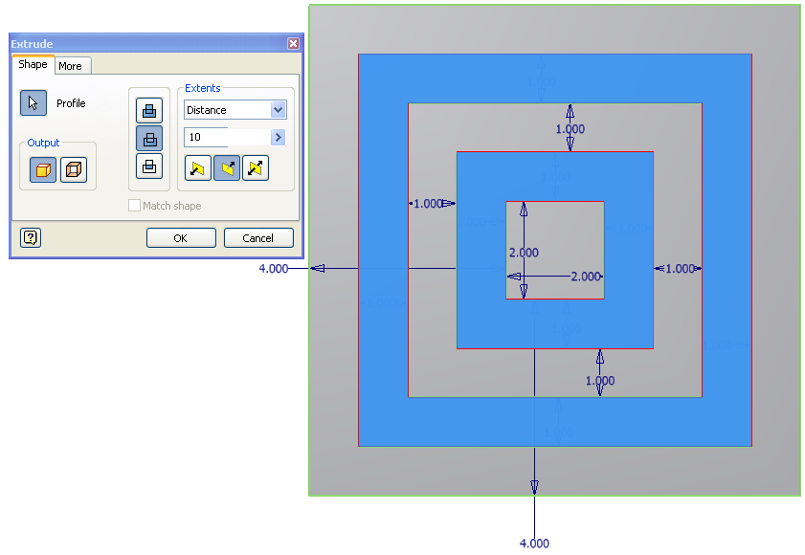
When you extrude this sketch, you want to extrude the outside square and the 2nd square, just like we did for the circle.

Spin is around a bit and check it out.

Our next sketch will be on the top, but check to see that your neighbors need help first.

I’ll let you know what we are doing next in a moment.

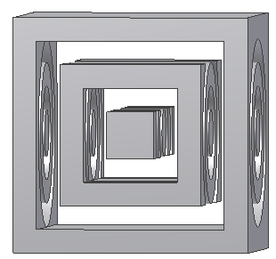
Now we have two parts of the TARGET part completed.

You have circles cut through front and back, and squares cut through left and right.

Your part should look like the part you see here on the right. If it does not, raise your hand for help, or ask a neighbor to help you out if their part is correct.

Our next sketch is on the top of the part, so look at the top, right click on it, and choose NEW SKETCH to get your gridlines back up.

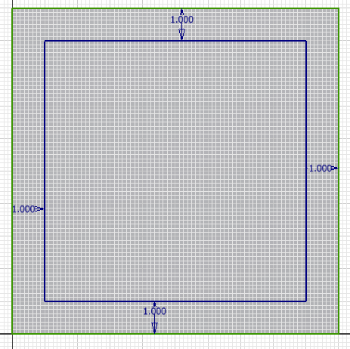
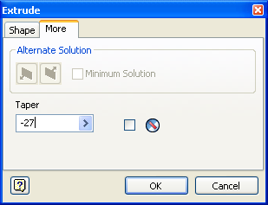
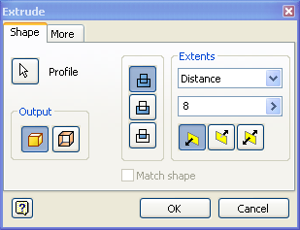
- On the top side of the box, we will make a two point rectangle.
- Dimension each side of the rectangle 1 inch from the edge of the box.
- Extrude the rectangle 8 inches, BUT DO NOT HIT OK!!!
- Click on the More tab.
- We want to TAPER our extrusion.
  - A taper is an angled extrusion. The angle can range from 89 degrees (going way out) to -89 degrees (coming way in).
  - We want to form a pyramid, so we want it to come in and will use a negative number.
  - Our taper should be a -27 to get the largest possible pyramid.
  - AFTER you have put in your taper, you may hit OK.

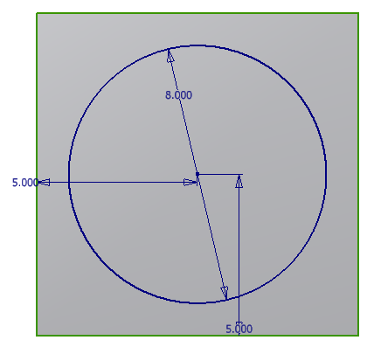
It is time to draw on the bottom side of our part.
    - Look at the bottom side of your part.
    - Draw a center point circle.
    - The diameter of your circle needs to be 8 inches.
    - The center point of the circle needs to be 5 inches from the left side and 5 inches from the bottom side of that face.
    - Your dimensions should look just like what you see here when you go to the 3D screen to EXTRUDE.
    - Join your circle 8 inches to the block.
    - Taper is to -27 degrees.
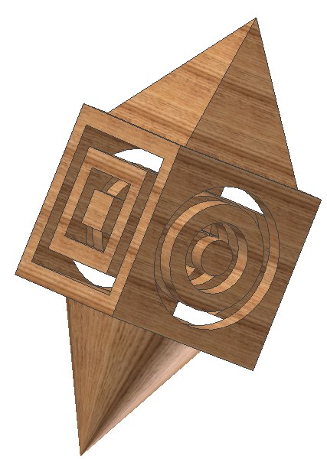
    - You should now have a circular cone on the bottom of the block.
Next we want to color your block. We will do this initially by choosing the As Material Pull-down Tab in the left center area at the top of your screen. It is just right of the Save icon. If you cannot see your tab, please raise your hand.

You can choose whichever color you like from this menu. It will change the entire piece to that color. For instance, I chose Wood that is Oak in color, so now my whole piece is OAK.

But using just one color is boring. I can also choose to color individual pieces of my part different colors. Here is how you do this.
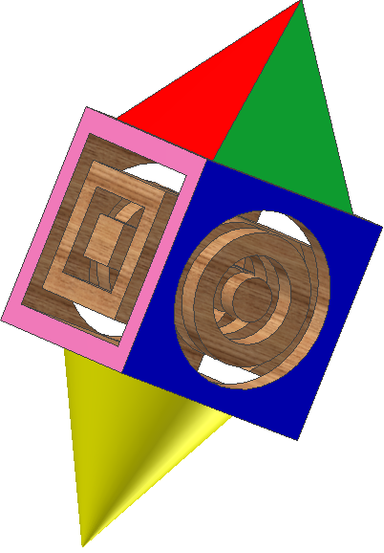
- Left click on something and turn it blue. Let’s try the cone first. Left click it.
- Now that it is blue, right click the cone.
- Choose PROPERTIES
- This new window has all the colors at your disposal again. Make the cone its own unique color.
- You can color multiple pieces at once by holding down shift while you left click them. Then just right click one of the highlighted areas and set the colors for all of those selected places at once.
- Your target part must have AT LEAST 10 DIFFERENT COLORS in it when you are done.
- Have fun coloring your TARGET.IPT part.
- Make sure you have saved it as TARGET.

