SKETCHING TYPES AND DEFINITIONS

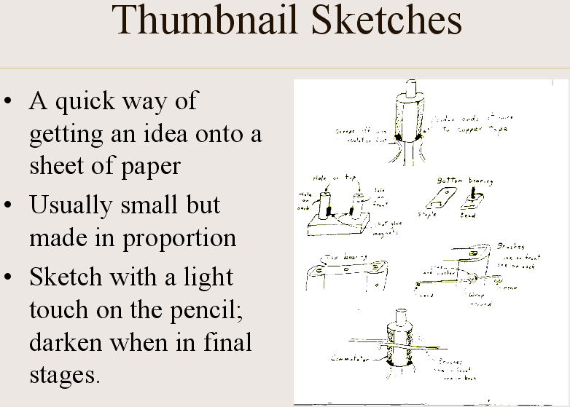 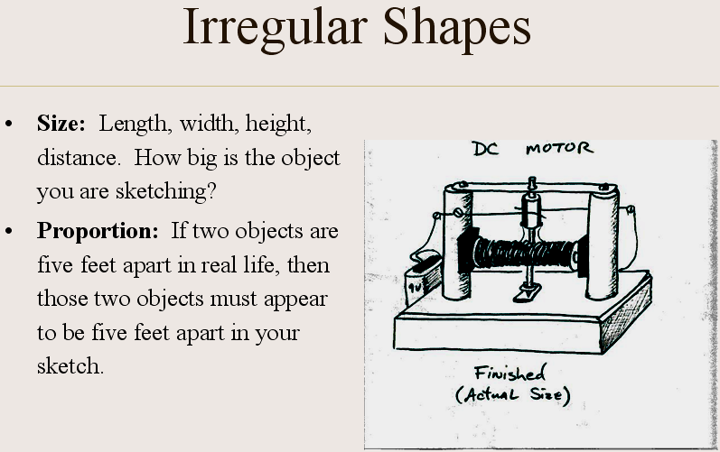

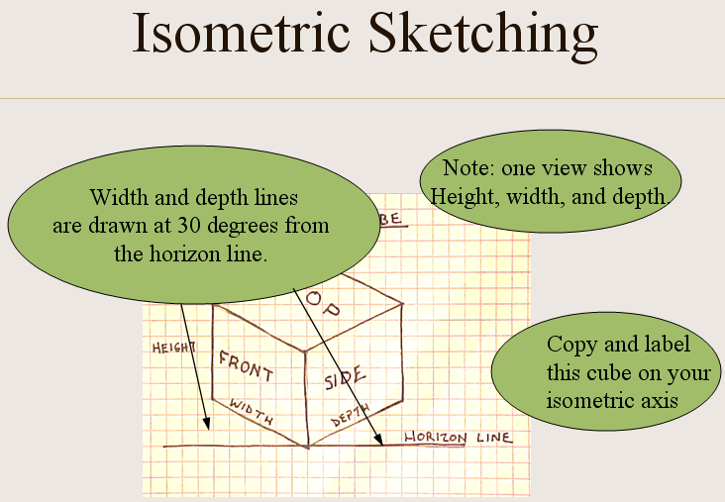 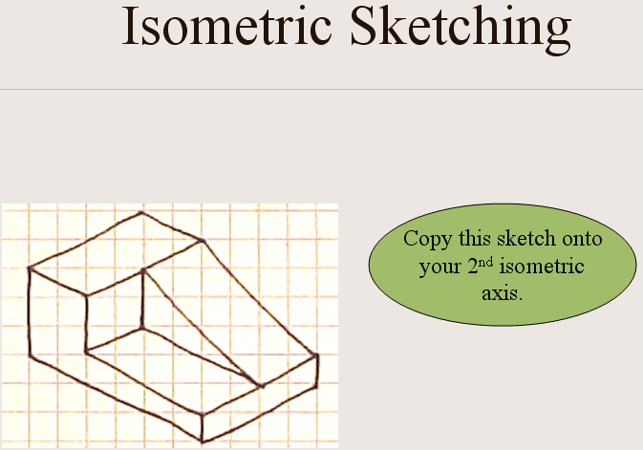

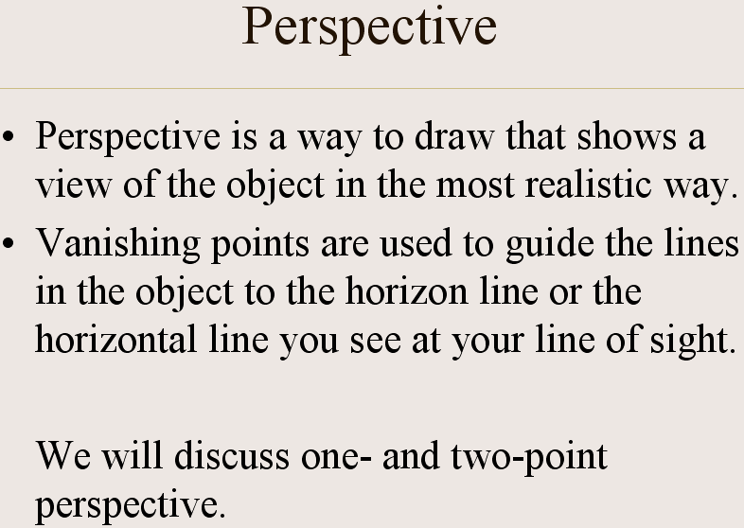 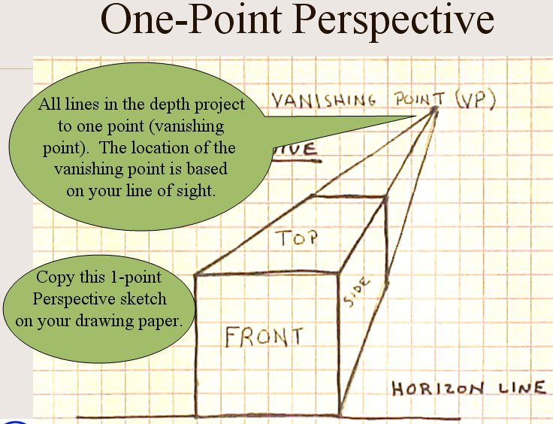

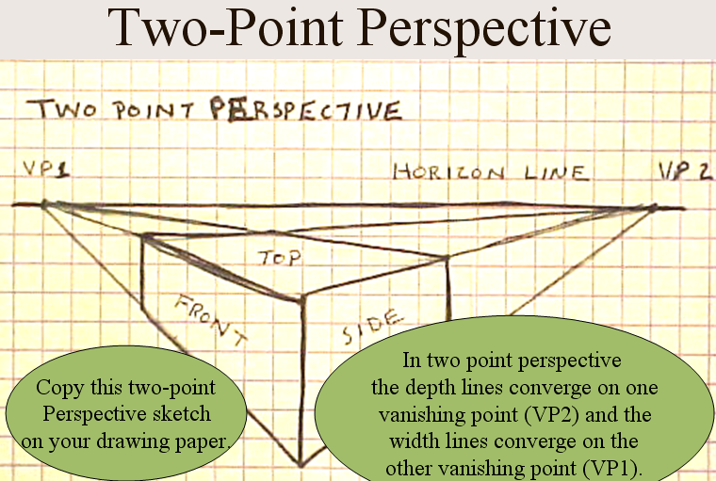 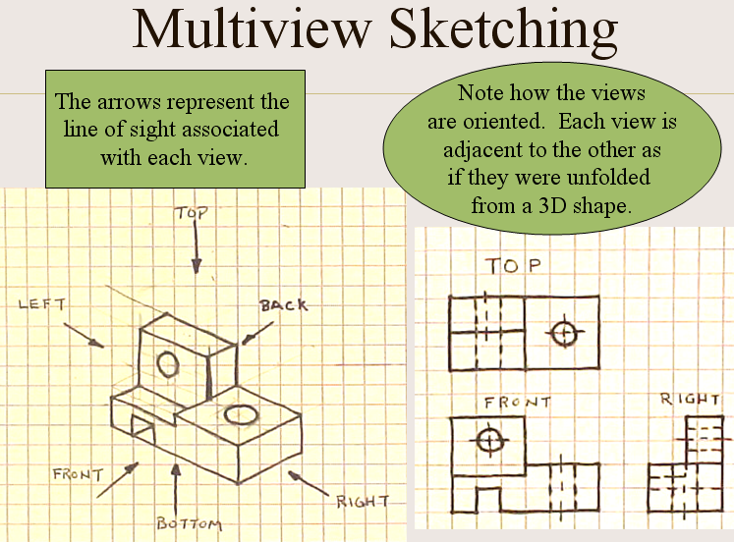

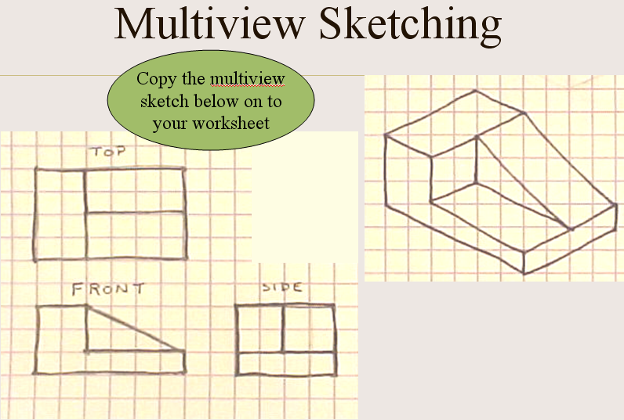

You should know how to recognize all of these drawing types AND be able to draw an example of each.

There will be a test on this information, as well as the information in the final three pages of your packet. Use the back three pages of this packet as your study guide for the test, but also know how to draw all of these sketching types.

An important skill you should learn while taking technology is the skill of sketching. This language is quick, easy, and worth a “thousand words.” I know some of you say, “I can’t draw or my drawings look awful!” If you stay with some of the techniques I’ll show you, I know all of you will be successful in being able to quickly and effectively place your ideas down on a sheet of paper for all to understand.

**Thumbnail sketch:** This is a very quick way of getting an idea onto a sheet of paper. A sketch is usually small but made in proportion, the relationship of height to width. It is recommended that you use the pencil very lightly and darken when the drawing is in its final stage. A thumbnail sketch needs to be as detailed as necessary to convey your idea.

j0212001 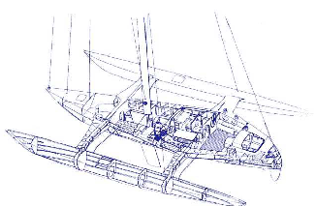

**Perspective Drawing:** Perspective drawings are pictorial representations of objects because they look like a photograph or like the “eye” sees it. Geometrically, an ordinary photograph is a perspective. While perspective is of major importance to the architect, industrial designer, or illustrator, the engineer at one time or another is certain to be concerned with pictorial representations of objects.

**One-point perspective:** In a one- point perspective, an object is situated with one face parallel to the plane of projection; only one vanishing point is required.

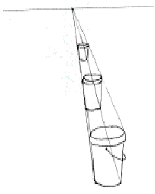

**Two- point perspective:** In this type of perspective drawing, the object is situated at an angle with the picture plane but with vertical edges parallel to the picture plane. Two vanishing points are required due to the turning of the object from the picture plane; the result is a two- point perspective. This is the most common type of perspective drawing.

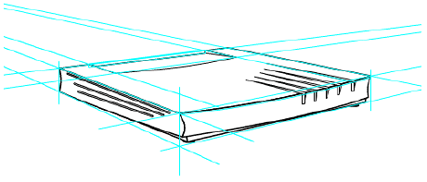

**Orthographic Drawing (commonly referred to as multi-view drawing):** A photograph or a perspective drawing shows an object as it appears to the observer, but not as it truly is. Such a picture cannot describe the objects fully, no matter from which direction it is viewed. It is said that it doesn’t show TS& S [true size and shape]. What is needed in industry is a complete and accurate description of the shape and size of an object that in the end will be made by the manufacturer. In order to provide information clearly and accurately, a number of views are needed and systematically arranged so anyone in the world can understand. Using Universal Language Drawing practices with many views to describe an object accurately and clearly is called Multiview Drawing or Orthographic Drawing.

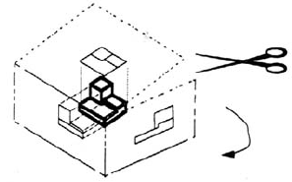

You will learn to look at objects in technology in a way “normal humans” do not. When you look at an object, as a human, you see three different dimensions [width, height, depth] all at once [sounds like a perspective drawing]. In an orthographic drawing, you will be looking at the object in three different ways. You will look at the front view and get two dimensions – height and width; the top view shows width and depth; and, finally, the right side view shows height and depth. You must also keep in mind that this is a Universal Language; therefore, where the drawer positions the views is standard. The front view is placed in the lower left, top is placed directly above the front view, and the right side view is placed to the right of the front view.

