Student Name: _________________________________ Reteach
Project 1
Standards
Required | Standard | I.D.O.E. Requirements
Part 1 | 6-8.LST.7.1 | Conduct short research assignments and tasks to answer a question (including a self- generated question), or test a hypothesis, drawing on several sources and generating additional related, focused questions that allow for multiple avenues of exploration.
Part 2 | 6-8.LST.7.3 | Draw evidence from informational texts to support analysis, reflection, and research.
Part 3 | 6-8.LST.6.1 | Plan and develop; draft; revise using appropriate reference materials; rewrite; try a new approach; and edit to produce and strengthen writing that is clear and coherent, with some guidance and support from peers and adults.
Part 4 | 6-8.LST.5.2 | Write informative texts, including scientific procedures/experiments or technical processes that include precise descriptions and conclusions drawn from data and research.
Part 5 | 6-8.LST.7.2 | Gather relevant information from multiple sources, using search terms effectively; annotate sources; assess the credibility and accuracy of each source; and quote or paraphrase the data and conclusions of others while avoiding plagiarism and following a standard format for citation (e.g., APA or CSE).
Part 6 | Tech 1-A | Define how technology helps improve, manage, and control the natural and human-made environments. A. Explain the purpose of technology
Part 7 | Tech 1-B | Define how technology helps improve, manage, and control the natural and human-made environments. B. Note how technology influences life, in current form or hypothesizing future technologies.

For any standard that you score below proficient (less than a 3), the student is required to complete the appropriate makeup assignment listed above to prove readiness before the student can attempt a retest for proficiency.

Standard | Explanation | Your Score
6-8.LST.7.1 | Gather relevant information from several sources.
6-8.LST.7.3 | Draw evidence to support analysis and research.
6-8.LST.6.1 | Plan and develop a draft (web or outline creation)
6-8.LST.5.2 | Write informative texts including precise descriptions and conclusions drawn from data and research.
6-8.LST.7.2 | Assess credibility & accuracy of sources in research.
Tech 1-A | Explain Purpose of you Technology Choice
Tech 1-B | Explain previous technologies leading to it.
Tech 1-B | Hypothesize future changes to influence life.

PARENT SIGNATURE REQUIRED: ___________________________

PART 1: Research project to acquire notes using AT LEAST THREE DIFFERENT SOURCE S

RESEARCH TOPIC: Alkali Metals
- The student is required to find at least three websites on this topic and write out or copy and paste THE ENTIRE WEBSITE URL ADDRESS in order for the information to be traced.
- The student is required to take notes that include the following:
  - At least 3 different properties that all Alkali Metals share.
  - A list of all Alkali Metals.
  - At least one unique way that each alkali metal is used, including citing which website gave that information.

PART 2: Drawing evidence from Informational texts to support analysis, reflection, or research.

ANALYSIS TOPIC: Prosthetic Limbs
New York Times Article
http://www.nytimes.com/2015/05/21/technology/a-bionic-approach-to-prosthetics-controlled-by-thought.html?_r=0
- Student is required to read the article from the New York Times and take detailed notes about the research going on today in prosthetics to positively affect the lives of humans.
- The notes should detail what the prosthetics are capable of doing, how they do it, how they are controlled, and what still has to be done in order for it to help the most people.
- Student should write a few sentences to a paragraph at the end of their notes reflecting on this technology with any personal ideas, thoughts, or opinions.

TECHNOLOGY | ROBOTICA EPISODE 3

Prosthetic Limbs, Controlled by Thought
By THE NEW YORK TIMES MAY 20, 2015

Engineers at the Johns Hopkins University Applied Physics Lab have developed a next-generation prosthetic: a robotic arm that has 26 joints, can curl up to 45 pounds and is controlled with a person’s mind just like a regular arm.
Researchers think the arm could help people like Les Baugh, who lost both arms at the shoulder after an electrical accident as a teenager. Now 59, Mr. Baugh recently underwent surgery at Johns Hopkins to remap the remaining nerves from his missing arms, allowing brain signals to be sent to the prosthetic.
Mr. Baugh’s custom socket can pick up brain signals to control the arms, known as Modular Prosthetic Limbs, or M.P.L., just by thinking about the movements.
Mike McLoughlin, the chief engineer of research and exploratory development at the lab, said that as the remapped nerves grew deeper, it was possible that Mr. Baugh would feel some sensation in his prostheses. Each arm has over 100 sensors, and other amputees who have had the same surgery reported being able to feel texture through the M.P.L.
Patients of varying disabilities have tested the arm in the lab and helped push the design forward.
The limb is modular, which means it can be broken off or built up to accommodate people with different needs — from a hand amputee to someone missing an entire arm. Quadriplegics or stroke survivors, who have lost the ability to move all or part of their bodies, can also use it as a surrogate arm.
But while the limb is fully functional, it still faces hurdles before making its way outside the lab. It will need approval from the Food and Drug Administration, which could mean a clinical trial.
Mr. McLoughlin also said the cost of the arm needed to be about a tenth of its current price to be viable in the marketplace. There are now about 10 fully functioning M.P.L.s, and each one costs an estimated $500,000.
“We’ve designed a Maserati here, but what most people will want is a good Toyota,” Mr. McLoughlin said. “The M.P.L. was intentionally designed to be as sophisticated as we could make it so that you could really push the state of the art, but ultimately for commercializing it, it needs to be a lower cost design.”
Since 2006, the lab has been awarded $120 million from a program run by the Pentagon’s Defense Advanced Research Projects Agency to help wounded warriors. The lab worked with technology developer and manufacturer HDT Global to make a prosthetic that mimics the human arm in dexterity and strength.
“The long-term goal for all of this work is to have noninvasive — no extra surgeries, no extra implants — ways to control a dexterous robotic device,” said Robert Armiger, project manager for amputee research at the Johns Hopkins lab. In the future, researchers envision a kind of cap with sensors that an amputee or paralyzed person could wear that would feed information about brain activity to the robotic arm.
The lab is starting to collaborate with industry partners to explore commercial opportunities. They hope the Modular Prosthetic Limb, or a version of it, will be available to consumers within a few years. — Emma Cott

PART 3: Plan and develop; draft; revise using appropriate reference materials; rewrite; try a new approach; and edit to produce and strengthen writing that is clear and coherent

ANALYSIS TOPIC: TORQ Roadster; the 3-wheel electric sports car.
- Student is required to create a web or an outline for a 3-paragraph paper they would write about the TORQ Roadster from EPIC ELECTRIC VEHICLES (2 pictures and several websites with information are listed below).
  - Each section of the plan is required to have a topic area that is going to be discussed and at least 3 different supporting pieces of information for that topic, which a phrase that will appear in their conclusion sentence for each paragraph. An example format on a totally different topic is shown below.
  - Plan can be in phrases and key words, SENTENCES NOT REQUIRED IN PLAN.
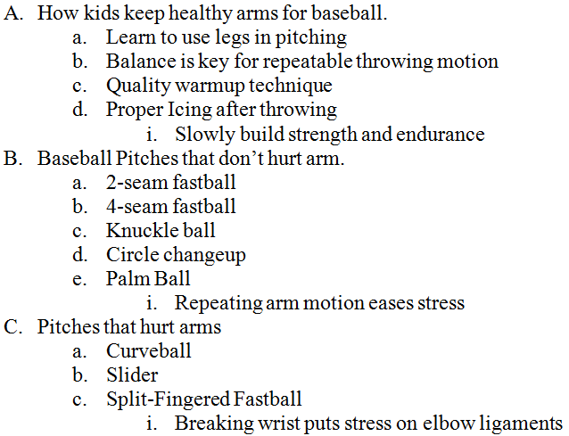
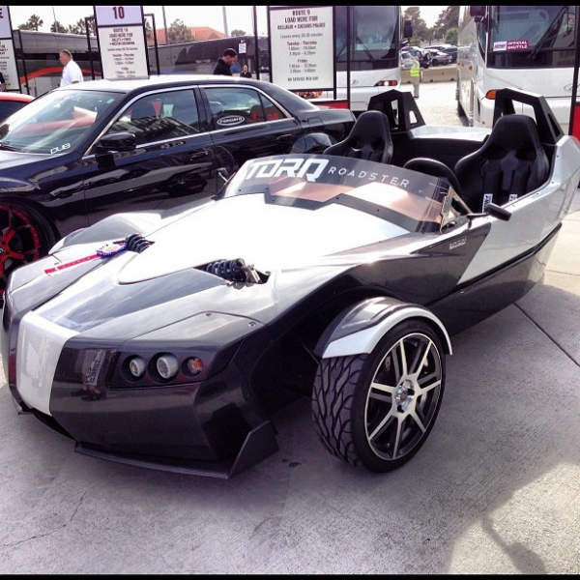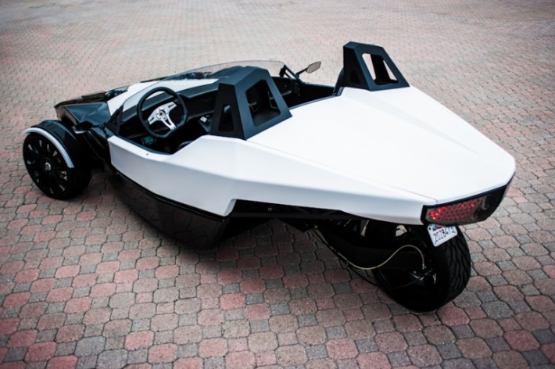
http://motrist.com/images/posts/1/0/553/10553_m.jpg
http://www.greencarreports.com/news/1083141_ex-aptera-founder-reveals-new-electric-sports-car-torq-roadster
http://realitypod.com/wp-content/uploads/2013/03/epic-torq-ev-roadster-5.jpg
TRANSLOGIC TEST DRIVE: https://www.youtube.com/watch?v=bsgsLDCJWPQ

PART 4, 6, and 7: Write informative texts, including scientific procedures/experiments or technical processes that include precise descriptions and conclusions drawn from data and research.
- Define how technology helps improve, manage, and control the natural and human-made environments.
  - A. Explain the purpose of technology (PART 6)
  - B. Note how technology influences life, in current form or hypothesizing future technologies. (PART 7)
- If student has a below proficient grade for both Technology Standards 1A and 1B (PART 6 and PART 7), student needs to do written paragraphs on each of parts two and three.

TOPIC: Either topic from Parts 2 and 3
- Student is required to write and information essay of at least two paragraphs in length. Each paragraph must have the following:
  - A topic sentence that all following sentences in that paragraph are going to be about.
  - AT LEAST 3 sentences providing support for the topic sentence.
  - A conclusion sentence at the end of the paragraph to wrap up their idea.
- FOR PART 6:
  - The students paragraphs must be focused on the purpose of their technology topic
    - What are the things that the technology is trying to accomplish?
    - What are some of the special ways that the technology device will do this?
- FOR PART 7:
  - The students paragraphs must be focused on how the technology influences life in our present and / or hypothesizing it’s affect into the future.
    - How does it improve the lives of those who use it and others around them?
    - How does it change the world?
    - What can this development lead to in the future that will make all lives better?
    - Etc.

