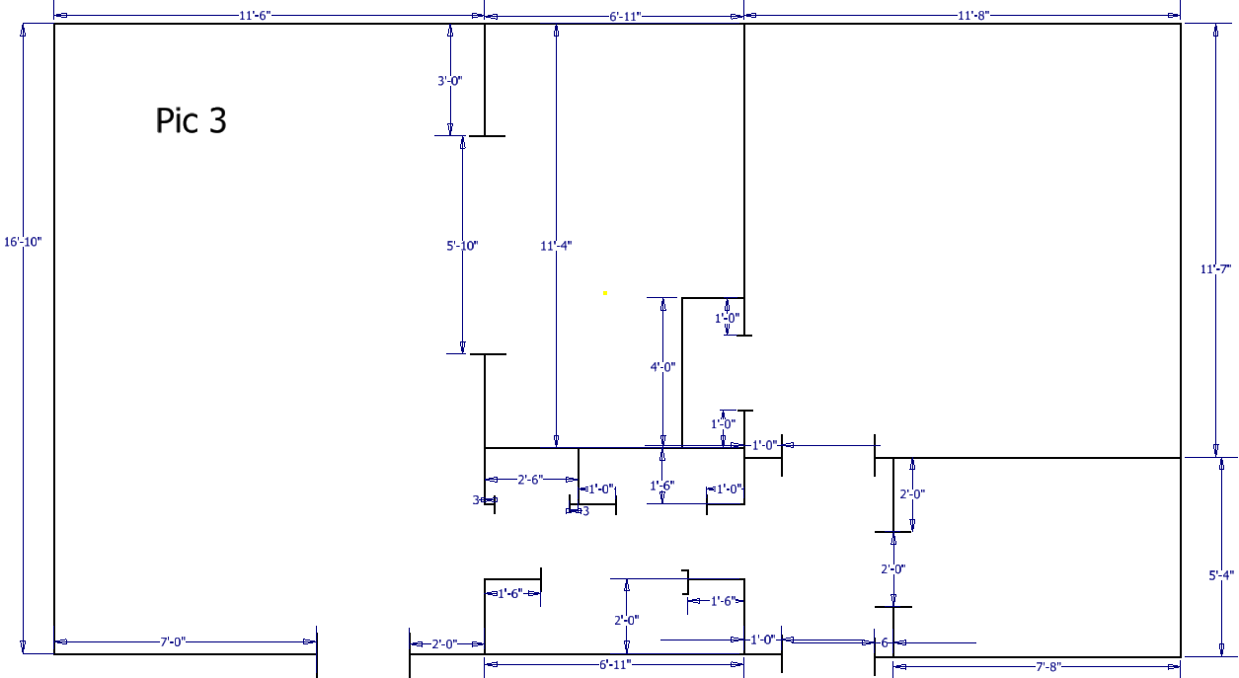

This picture is a floor plan of an apartment in New Jersey. This plan is done in Feet and Inches, so we have to do this part using the ENGLISH FOLDER. Choose at STANDARD(IN).IPT, and start a new sketch on any plane you want.
- When setting feet in your sketch, you must put an apostrophe (‘) after the number.
- When setting inches in your sketch, you must put a quotation mark (“) after the number.
- Please make sure that you set your feet and inches correctly.
- Remember, to make a doorway just put the rectangle down and TRIM the lines blocking the opening.

