Practice Shapes for scaled drawings.

3/4 “ Scale | 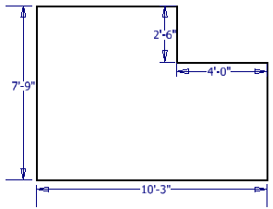  1/2 “ Scale
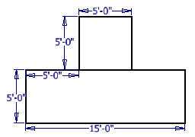  1/4 “ Scale | 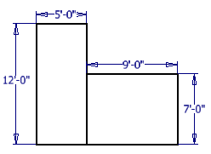  1/2 “ Scale
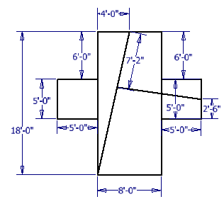  1/4 “ Scale | 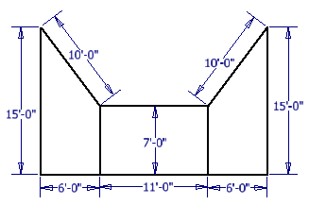  1/4 “ Scale

Each of these drawings must be drawn to scale. Each must be completed in pencil.
This layout is your first design and construction project. We will be drawing this and constructing it in a ¼ inch scale.  - Your drawing must be completed in pencil.  - Your drawing must be completed on unlined 11 x 17 paper.  - Your construction project should match your drawing.  - The floors will be constructed out cardboard.  - The walls will be constructed from Cardstock paper (120 lb.)  - All walls must be 10 feet tall.  - All doorways or openings must be 6’8” tall.  - The hallways do not have to be constructed, but the Foyer does have to be built.  - The Side entryways and doorways should be constructed.  - Three rooms, the bathroom, study, and laundry room do not have doorways shown. You must decide where they go and list their dimensions in your drawing, then match them in your construction. | 