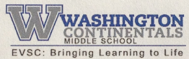 | 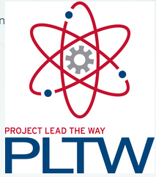 | 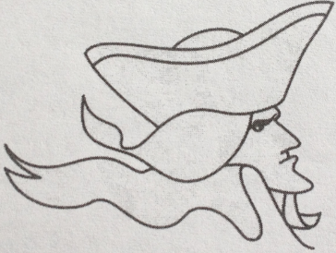
Mr. Motta’s Project Lead the Way Technology – Room 17/39
STEM Education – Science, Technology, Engineering, and Math

Mr. Motta’s E-mail Address: michael.motta@evsck12.com
Mr. Motta’s Class Website: http://mmotta.weebly.com/

Class Rules:
- You will bring pencil, Chromebook, and QUADRILE composition engineering notebook to class every day.
- You will treat EVERY PERSON with respect, and take no action to put any person in danger.
  - Disrespect to any person is unacceptable. Follow the Washington Middle School Continental ARMY code. Be Accountable, Respectful, Motivated to learn, and do Your best, but academically and in personal conduct.
  - Any dangerous action toward any other person will result in an immediate referral.
- You will take no action, verbal or otherwise, that will disrupt the function of learning.
  - Any action that disrupts learning will be noted. Class discipline policies will follow the following procedure:
    - First instance of Period: Verbal Warning
    - Second Instance of Period: Personal explanation of school rules
    - Third instance of Period: Referral to office.
  - Desktop computers will be used often in this class. Students not following the class lesson sites and/or improperly using this technology improperly will be dealt with using the same policy as above.
- You are responsible to care for your technology devices and use them properly
  - DO NOT go to sites that are obviously not appropriate.
  - Do not allow yourself to get distracted with sites outside the curriculum.
  - Have NO WINDOWS OR TABS OPEN beyond what we are using in class.
  - All students are expected to follow all EVSC and WMS technology policies at all times in this class. NO EXCEPTIONS.
  - When we are not using the Chromebooks in class, they must be closed. They can be open to take notes in class, but only the word processing software should be open in this case. No internet tabs should be open during note taking.

Class Plan/Syllabus for this year will be determined by the speed at which PLTW course supplies are acquired and class progress.

Class Extra Credit Policy: No extra credit assignments will be given for any reason. That is school policy at Washington Middle School.

Class Writing Expectations: All writing assignments in class are expected to show Washington Middle School writing rules. Complete sentences are required. Quality paragraph setups are required. Proper punctuation and voice are required. Spelling counts; do not write in “slang” or “text talk” (SMH, LOL, etc.).

Class Late Work Policy: Assignments are due in class at the time they are collected. If an assignment is not in class, it is late. All late assignments follow the school 2-week late work policy. If the assignment is not turned in within that 2-week time-period it will not be accepted.
- All assignments are due by the end of that grading period.
- If a late assignment is not turned in by the end of grading period date required for grade calculation by the teach, it will receive a proficiency grade of 1.
- Students absent on the date something is due to be turned in will follow the school absence policy for turning in late work.

Every student is expected to WORK HARD and WORK SMART, try their best EVERY DAY, and be prepared mentally to think through the problems to FIGURE OUT THEIR OWN BEST ANSWER. All who do these things will find success.

