Additional Activity – Early Measurement

Student Name: _______________________

Group #: _____
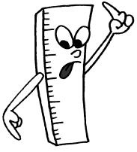
Directions: First, review the measures on the early measurement handout. You and a team member will use these “old time” measurement units to measure common classroom items and place your measurements in the chart below. Note that some units of measure may be smaller than what you are measuring. You may need to use a length of string to help you measure.
 | Palm | Fathom | Hand | Cubit | Foot | Stride | Girth
Lab table width
Lab table length
Lab table height
Lab partner’s height
Your height
Lab door width
Lab door height
White board length
Lab floors width
Lab floors length

Early Measurement History

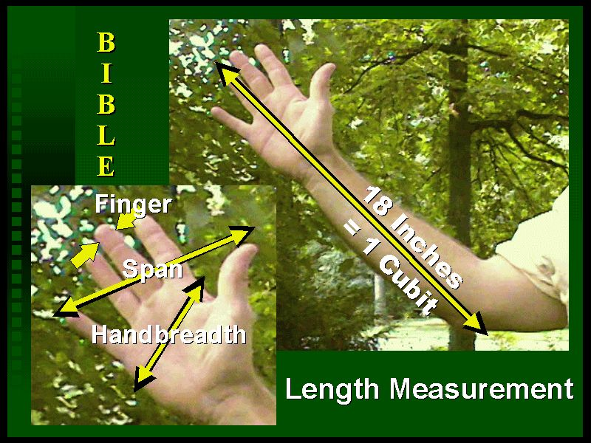

A cubit, used by the Egyptian’s to build the pyramids, is the measure from the tip of your middle finger to the tip of your elbow.
The fathom is the measure from fingertip to fingertip when your arms are stretch sideways as far as the can go. Some people call this your wingspan.
The hand/span is the measure from the tip of your pinky to the tip of your thumb when your hand is stretched out. You still hear people talk about horses as being so many hands high.
The pace (two steps: one-step is a stride) was used by the Romans to describe the rate of movement of their soldiers.
The girth is the measure around your stomach (your belt measure). Fishing line was measured in girths.
The width found by placing your four fingers together was known of as a Palm.

