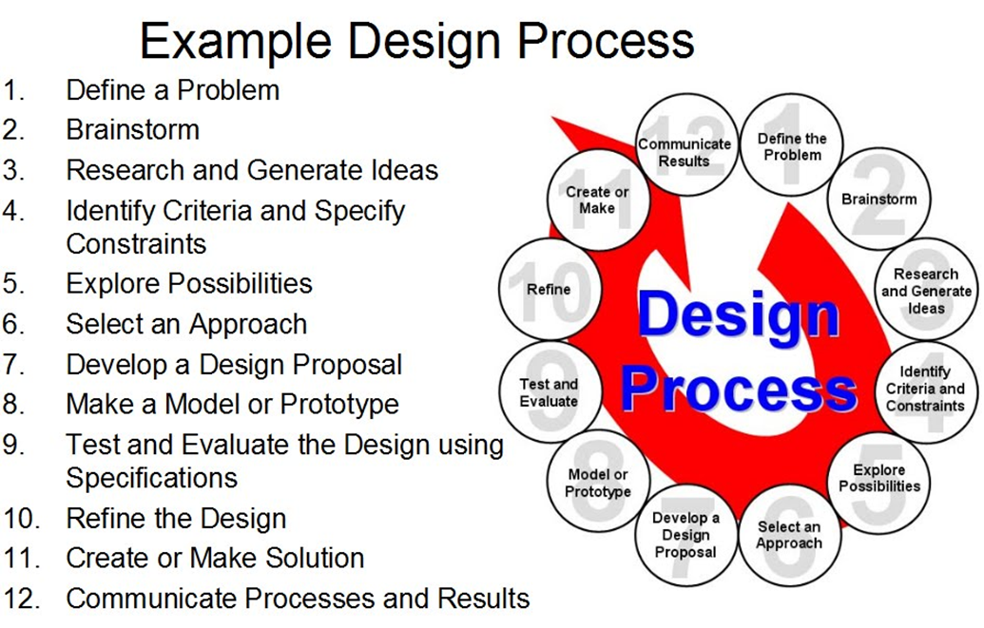

- Define a Problem: Determine specifically what you are attempting to fix or solve.
- Brainstorm: Unrestrained and spontaneous discussion of all participants to stimulate creative thinking.
- Research & Generate Ideas: Investigate brainstorm results to create more specific options.
- Identify Criteria (+) & Specify Constraints (—):Find the positive criteria and negative constraints for each specific choice available.
- Explore Possibilities: Break down the focused choices to determine the likelihood of success.
- Select an Approach: Choose the top three options and select the best one to try first.
- Develop a Design Proposal: Create a written document or oral presentation that explains what you would like to try to do in order to solve this problem.
- Make a Model or Prototype: Create a stand-still model or a working model, known as a prototype, that can be tested.
- Test & Evaluate Design Using Specifications: Run tests on the model or prototype to see how it performs in specific conditions.
- Refine the Design: Take the results from your experiment and use them to change your design to allow it to be more successful in future tests.
- Create or Make your Final Solution: Once refined design has passed the tests, make real world final versions of your design.
- Communicate Processes & Results: Create a written or oral presentation explaining what you did, what results were gathered from your tests, how well it works, and why it works that way.

