CAD DESIGN Using Autodesk Inventor
This page is a “cheat sheet” for you on zoom commands. Please feel free to write on it and take notes. You should have this sheet out EVERY DAY when you are working on Autodesk Inventor.
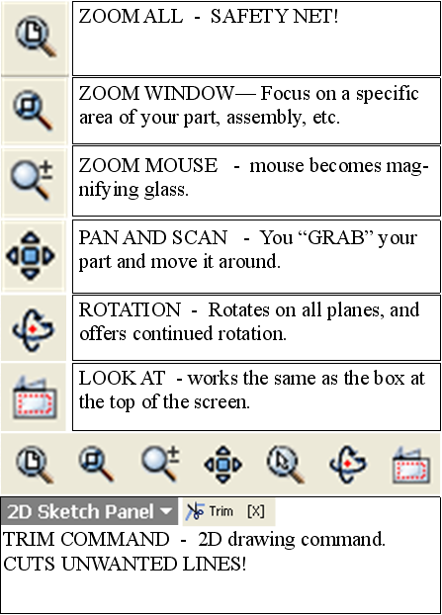
- Setting dimensions is the most common and important thing that you will do using Autodesk Inventor.
- Dimensions are the precise measurements of design.
- Once 2D lines and shapes are drawn, they must all be dimensioned in order to create precise designs.

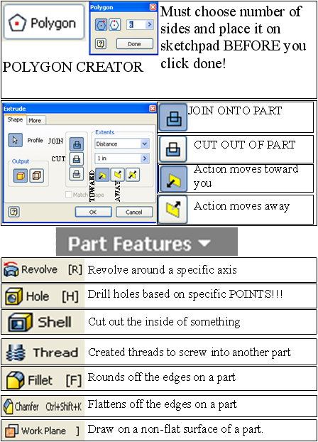
- Extrusions are the most common 3D command that will be used.
- Shells will be used to create the “rooms” in your pod.
- Fillets must be used to “round off” and “soften” your furniture designs. Chamfers can also be used, but are flattened edges.
- Work Planes must be used to draw on any rounded surface. New sketches cannot be drawn on areas that are not flat.

