

Activity 4.6 – Bracket

Purpose

Studying how something is fastened is not something you do every day. But, just for fun, consider looking at how your desk is held together or your locker. Most likely, you will notice they are held in place by different types of screws. The same is true with doors and windows. When you look at stairs and other objects, you begin to realize that things are held together in many different ways.

In this activity, you will be introduced to a 3D model that has counterbores and countersinks. These are two types of specialized holes used with fasteners. A countersink is used to recess the tapered head of a fastener below the surface of an object (i.e., like a screw on the chair you’re sitting in). A counterbore is a cylindrically enlarged hole, generally used to allow the head of a screw or bolt to be recessed below the surface of an object (i.e., on the back of a radio or television, they are the little holes for the screws).

Equipment

* Autodesk Inventor, using a Metric Part – Standard(mm).ipt
* Engineer’s notebook
* Pencil

Procedure

Using the same procedures you learned in previous activities, create a 3D model of the bracket depicted in the orthographic and isometric views provided.

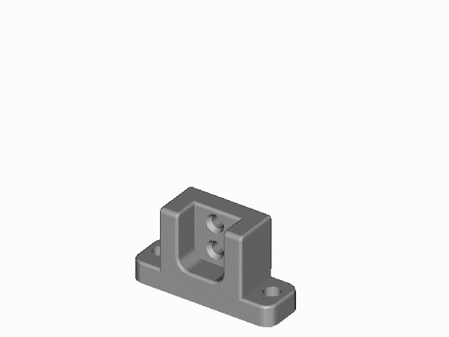

Figure 1: Bracket

Countersink

Counterbore

If you look at the orthographic drawings closely, you will see the difference in the profiles of the counterbore and countersink. They show up well in the right side view. This bracket might be used by being bolted to a solid surface through the counterbores, and having a lighter piece attached to the back using the countersunk holes.

In order for you to know how to create the holes, counterbore, countersink, fillets, and rounds for this project, you will need to follow the instructions of your teacher or complete the tutorials regarding these topics.

Orthographic and Isometric Views of Bracket:



Step-by-Step Procedure:

**NOTE: All measurements are in millimeters!**

1. From the File menu, select New File.
2. Select Metric Tab
3. Start a Standard (mm).ipt and choose the central/horizontal plane.
4. Sketch a two point rectangle
5. Add dimensions making it 87 x 156.
6. Finish the Sketch and **Save the file with the name of Bracket.**
7. Extrude the sketch to a distance of 50.
8. The next step is to cut away the sides. Create a new sketch on the front of the part.
9. Use the rectangle command to draw a shape similar to the sketch in Figure 2. Be sure to get the coincident constraint on the top line and the side line.
10. Add dimensions shown.
11. Extrude



Figure 2: Rectangle Sketch

1. In order to create the notch on the right side of the object, Cut all the way through your part. Make sure the arrow is pointing through your part.
2. Repeat on the other side. Your part should now look like Figure 3.



Figure 3: Bracket with notched sides and sketch on the front of the part

1. Create a new sketch environment for the notch in the middle of the part.
2. Create the rectangular sketch on the front of the part, 50 x 29. You can use the rectangle command.
3. Dimension the sketch so it is 21 mm from the right side as well.
4. Extrude the sketch into the part. Use the Cut operation, and a depth of 27.
5. We will now add the counterbores. These are placed features and require a sketch. Start a new sketch environment on the surface where the counterbore will go. Use the point command to place a Hole on the surface. You must dimension it like you see below. It should be 23mm from the back edge and 16mm from the side. When done dimensioning, finish your sketch.

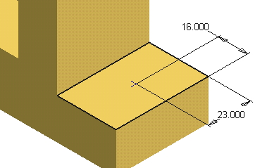

1. Use the Hole Command and Counterbore. Enter 13 for a hole diameter, 18 for a counterbore diameter and 10 for a depth. Select OK.

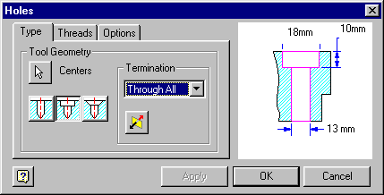

The counterbore.

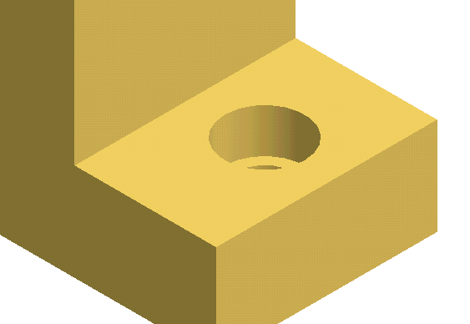

1. Repeat the steps to create an identical hole for the other side.
2. Now it is time to put the countersinks into the back surface. These are placed features and require a sketch. Start a new sketch environment on the back wall.

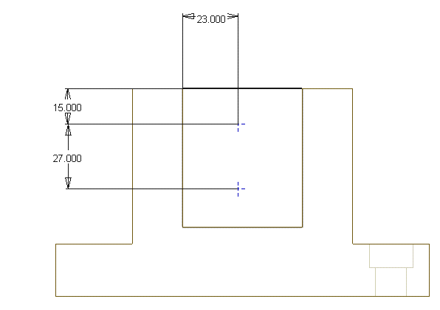

1. Place a point for the hole centers which will be countersinks. Dimension them to be 23 from the left side, and 15 and 42 mm down from the top.
2. Use the Hole Function to place the countersinks. Use 20 for the counter sink diameter, 13 for the diameter of the hole and trough all for termination.

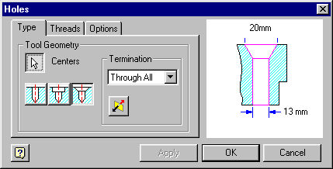

1. Fillets are also added features. Select the fillet feature. Radius is 12. Click OK and select the four lower vertical lines that make up the corners, the two horizontal lines that make up the sides of the bottom of the slot, and the two horizontal lines at the intersection of the front and the top. Click OK.

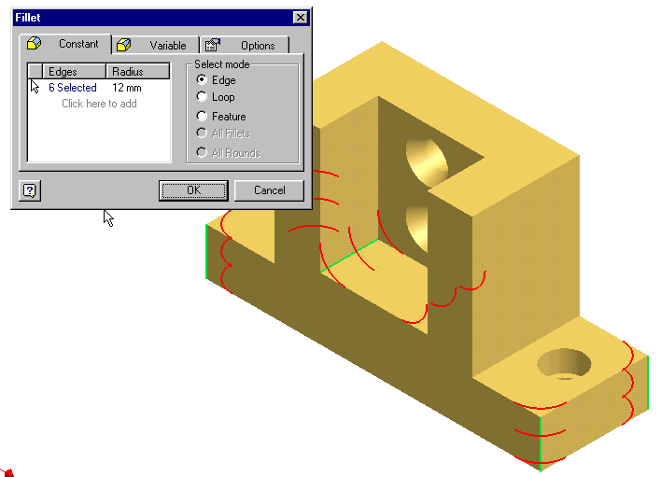

1. The final fillets are applied to the rest of the surface to create the rounds needed for casting. The radius is 3 mm.

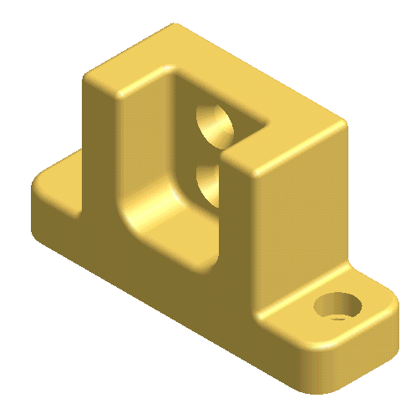

Finished Bracket!

Conclusion

Using Mass Properties

1. What is the total mass of the part if is made from yellow brass?
2. 42,345 g
3. 423,450.2 g
4. 236 g
5. 3169582.66 g
6. What is the volume of the part?
7. 374,212.8 cm3
8. 245,439.3 cm3
9. 634,294.2 cm3
10. 2,124 cm3
11. What is the total mass of the part if is made from mild steel?
12. 4372543.5 g
13. 5234988.3 g
14. 2941312.8 g
15. 5234215.5 g

Further Thinking:

# What would be another way of creating the basic shape of this part?

1. What would be the advantage of a counterbore over a drilled hole?
2. Why are the cheeks of the countersink cut at an angle?
3. How come both features would be used on the same part?
4. At home, find five items that have a countersink and five items that have a counterbore. Write them down.

Supplemental Information:

Density of Brass is 8.470 g/cm3